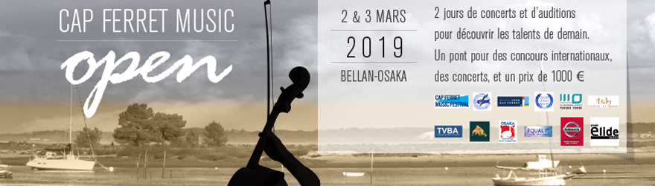

CAP FERRET MUSIC OPEN
2-3 March 2019
CAP FERRET, GIRONDE, FRANCE

2 days of concerts, auditions
to discover tomorrow’s talents.
A bridge to 3 international competitions,
concerts and a 1000 euro prize.
PARTICIPATE
Procedure / Rules : The event consists of a public audition in the presence of directors or representatives of the 3 international competitions, the artistic management team of the Cap Ferret Musical Festival and well known musical persons. With its wide artistic scope, this competition suits solo performers or group ensembles from a large spectrum of disciplines. There is no age limit. The program is free and lasts around 15 minutes. National and regional press give good coverage of the event.
3th March at 4pm the artists selected for the following will be announced :
- Dispensation for qualifying rounds for the Léopold Bellan Competition from 27 OCTOBER- 3 November 2019
- Direct access to the final of the Osaka International Music Competition from 1-15 October 2019
- Performance at the final concert 3th March at 5pm.
3th March after the final concert the jury will designate:
- The winner of the 1000 euro prize sponsored by Nissan Ares.
- Participation at concerts in the Saint Bonnet Theatre (Bourges), Lege Cap Ferret, ‘Pole Superieur’ Bordeaux Aquitaine and other venues.
- A scholarship for the Cap Ferret Music Festival 2019 ( Masterclass/concert / accommodation)

Enrolment
A 50 euros fee is required from each solo performer or group enrolled. Places available for 1-2 nights in B&B for the applicants.( Participating musicians only) . The fee also covers the enrolment costs for the Cap Ferret Music Festival 2019.
On line application on http://www.capferretmusicfestival.com/preselections.html
Performance times will be forwarded by mail and posted on the website and Facebook
Information/ questions will be answered only by e mail. open@ferretfestival.com
PROGRAM
Saturday 2 March 2019 public auditions 13.30 / 18.00 pm
8.30 pm Concert QUATUOR AVENA
Sunday 3 March 2019 public auditions 10 am - 3 pm)
5 pm Concert - first part : Winners Open 2019
-Second part : PIANO DUO MOUSAION

ABOUT
The Cap Ferret Music Open is a springboard for classical music, jazz and traditional which welcomes young professionals from France and abroad. It gives access to 3 major international competitions.
In partnership with a lot of competitions, the Music Open is recognized for the quality of the artists participating and the media interest created.
Through the initiatives of the “Sons d’Avril association”, instigator of the CFMF together with the Lege Cap- Ferret municipality, the Music Open provides two days of musical discovery together with two exceptional concerts unanimously appreciated by the public.
Since 5 years, the winners have been able to go abroad to claim prestigious prizes and concert in all the word. Such examples are Trio Sora, Duo Alma, Basha Slavinska, the” Le Plisson” Quartet, the soprano Alexandra Marcellier or Marie-Andrée Bouchard Lesieur.
The unmistakable atmosphere of the Cap- Ferret ensures that the Music Open is a winter event one cannot miss.
We specially thanks the Nissan Ares company for their kind patronage.

Adress and access
SALLE DE LA FORESTIERE,33970 CAP FERRET, France
60 kms from Bordeaux, Nouvelle Aquitaine
CAR from Bordeaux ring road take exit 11 towards CAP FERRET
TRAIN + BOAT Get off at Arcachon (SNCF line), then take UBA sea shuttle +33(0)5-57-72-28-28
TRAIN + BUS get off at Bordeaux-St-Jean then take CITRAM bus, line 601, stop "les Fauvettes"
PLANE Bordeaux Mérignac airport then take taxi or car rental or Bus line 1 stop Merignac Soleil, then bus 601 for Cap Ferret stop "les Fauvettes"

Principal jurys members :
Hélène Berger, pianist, composer and teacher ; founder and director of Cap Ferret Music Festival and Cap Ferret Music Open, manager of Concours International Léopold Bellan.
Rémi Guillard, président of Concours Léopold Bellan, teacher of master in CRR de Paris, teacher of Schola Cantorum and composer.
Franck Ciup, pianist composer ; artistic director of Théâtre Saint Bonnet.
ELIANE LAVAIL, artistic director of Madrigal de Bordeaux, Ensemble Vocal d’Aquitaine, and the very important Polifonia (…), honorary teacher of Conservatoire Régional de Bordeaux
Piano Accompanist :
France Desneulin, pianiste accompagnatrice au Conservatoire à Rayonnement régional de Bordeaux et Pôle Supérieur d’Enseignement Musique et Danse de Bordeaux.
